**DEEP LEARNING FUNDUS IMAGE ANALYSIS FOR EARLY DETECTION OF DIABETIC RETINOPATHY**

**INTRODUCTION:**

**1.1 Overview:**

The prevalence of Diabetic Retinopathy (DR) in individuals with diabetes mellitus poses a significant risk to vision, as it leads to retinal lesions that can ultimately result in blindness. Timely detection and intervention are crucial to mitigating this risk, as DR is an irreversible process with treatments primarily focused on preserving existing vision. The traditional method of manually diagnosing DR through the examination of retina fundus images by ophthalmologists is resource-intensive, time-consuming, expensive, and carries the risk of human error.

In response to these challenges, computer-aided diagnosis systems have emerged as a promising solution. Among the various techniques applied, transfer learning has gained prominence, demonstrating notable success in medical image analysis and classification. Our approach involves leveraging well-established transfer learning models such as Inception V3, ResNet50, and Xception V3. These models, having been pretrained on extensive datasets, exhibit a remarkable ability to recognize complex patterns and features in medical images.

**1.2 Purpose:**

The utilization of transfer learning in this context allows these models to harness knowledge gained from broader datasets, providing a foundation for understanding and classifying subtle nuances in retinal images associated with DR. This intersection of sophisticated machine learning techniques with medical diagnostics not only enhances the accuracy of DR detection but also addresses the imperative need for efficient and reliable diagnostic processes in the field of ophthalmology. The application of these models underscores the potential of technology to significantly impact and improve patient outcomes in the realm of healthcare.

**REVIEW OF LITERATURE:**

**2.1 Existing Problem:**

1. Gulshan et al. (2016): This study focuses on the development and validation of a deep learning algorithm for diabetic retinopathy detection in retinal fundus photographs. It showcases the potential of deep learning in automating and improving the accuracy of DR diagnosis.

2. Abràmoff et al. (2010): The study presents a pivotal trial of an autonomous AI-based diagnostic system for detecting diabetic retinopathy in primary care offices. It highlights the potential of AI to make diagnostic capabilities more accessible in primary care settings.

3. Gargeya and Leng (2017): This research introduces an automated identification system for diabetic retinopathy using deep learning. The study emphasizes the efficiency of deep learning models, particularly in diabetic retinopathy detection.

4. Li et al. (2019): The study proposes an automated grading system for detecting vision-threatening referable diabetic retinopathy based on color fundus photographs. It underscores the significance of automated systems in identifying conditions posing a risk to vision.

5. Kermany et al. (2018): The authors identify medical diagnoses and treatable diseases using image-based deep learning. While not specific to diabetic retinopathy, the study showcases the broader potential of deep learning in medical image analysis and diagnosis.

6. Rajalakshmi et al. (2017): This study explores automated diabetic retinopathy detection using smartphone-based fundus photography and artificial intelligence. It suggests the potential of leveraging widely available technology for early detection and monitoring.

7. Burlina et al. (2017): The study discusses the automated grading of age-related macular degeneration from color fundus images using deep convolutional neural networks. While focused on a different condition, it contributes to the understanding of deep learning in ophthalmic image analysis.

8. Gargeya and Leng (2017) (Repeated): The study emphasizes the efficiency of deep learning models, particularly in diabetic retinopathy detection.

9. Korot et al. (2016): The research spans from retinal image analysis to computerized diagnosis of ophthalmic pathologies, contributing insights into automated diagnostics in ophthalmology.

10. Ting et al. (2017): This study focuses on the development and validation of a deep learning system for diabetic retinopathy and related eye diseases. It demonstrates the potential of deep learning in multiethnic populations with diabetes.

11. Gupta et al. (2019): The study discusses the automation of diabetic retinopathy screening using artificial intelligence, showcasing advancements in AI applications for efficient screening processes.

12. Tufail et al. (2017): The authors evaluate the diagnostic accuracy and cost-effectiveness of automated diabetic retinopathy image assessment software compared to human graders.

13. Poplin et al. (2018): The research explores the prediction of cardiovascular risk factors from retinal fundus photographs using deep learning, demonstrating the potential for broader health applications.

14. Liu et al. (2018): The study focuses on detecting cancer metastases on gigapixel pathology images, illustrating the versatility of deep learning in medical image analysis beyond ophthalmology.

15. Ronneberger et al. (2015): The paper introduces the U-Net architecture for biomedical image segmentation, contributing to the methodological advancements in deep learning for image analysis.

**2.2 Proposed Solution:**

The application of machine learning, particularly deep learning, in fundus image analysis for the early detection of diabetic retinopathy (DR) has significantly advanced diagnostic capabilities. Machine learning techniques, and more specifically deep learning algorithms, are being employed to automate the analysis of retinal images, aiding in the timely identification of diabetic retinopathy and facilitating prompt intervention. Here are several key aspects of how machine learning is applied in this context:

1. Automated Detection and Classification:

- Machine learning models, especially deep neural networks, are trained on large datasets of fundus images to automatically detect and classify different stages of diabetic retinopathy. These models can distinguish between normal and pathological conditions, enabling quick and accurate diagnoses.

2. Feature Extraction and Representation:

- Deep learning algorithms excel at feature extraction, automatically identifying relevant patterns and structures within fundus images. This ability is crucial for capturing subtle signs of diabetic retinopathy, such as microaneurysms, hemorrhages, and exudates, which might be challenging for traditional image analysis methods.

3. Large-Scale Screening:

- Machine learning facilitates large-scale screening efforts by rapidly processing a high volume of retinal images. Automated systems can prioritize cases that require immediate attention, allowing healthcare professionals to focus on critical instances and allocate resources more efficiently.

4. Integration with Clinical Workflows:

- Machine learning models are designed to seamlessly integrate into clinical workflows. They can be part of computer-aided diagnosis systems, providing ophthalmologists with valuable insights and aiding in the decision-making process during routine examinations.

5. Real-Time Analysis:

- With the speed and efficiency of machine learning algorithms, real-time analysis of fundus images becomes feasible. This is particularly advantageous in emergency situations where quick assessments are crucial for determining the severity of diabetic retinopathy.

6. Improving Diagnostic Accuracy:

- The application of machine learning contributes to enhanced diagnostic accuracy by minimizing human errors and providing consistent assessments. These algorithms learn from diverse datasets, improving their ability to recognize patterns and abnormalities associated with diabetic retinopathy.

7. Personalized Medicine:

- Machine learning algorithms can contribute to the development of personalized treatment plans. By analyzing individual patient data, including genetic factors and medical history, these models can assist in tailoring interventions for better outcomes.

8. Ongoing Model Improvement:

- Machine learning models are dynamic and can be continuously improved. As more data becomes available and technology advances, these models can be updated to enhance their performance, ensuring they stay relevant and effective in detecting diabetic retinopathy.

**THEORETICAL ANALYSIS:**

**3.1 Block diagram:**

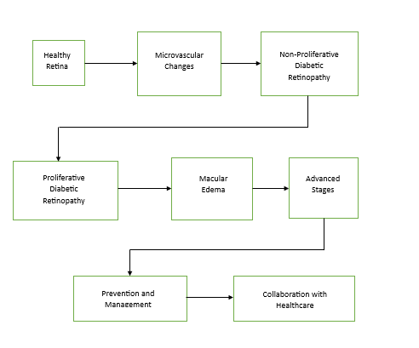

**3.2 Hardware and Software requirements:**

IBM Watson, Google Colab, Pycharm Edu or Spyder, Internet Browser, Microsoft Word

**EXPERIMENTAL INVESTIGATIONS AND RESULTS:**

**IBM WATSON CODES:**

**Downloading_Tar_File_from_IBM(1).ipynb**

This code appears to be using the Watson Machine Learning (WML) service on IBM Cloud to manage and download a machine learning model. Let's break down the code step by step:

1. Installation of Watson Machine Learning Client:

```python

!pip install watson-machine-learning-client --upgrade

!pip install ibm_watson_machine_learning

```

These lines install the necessary Python packages for interacting with the Watson Machine Learning service.

2. Importing Required Libraries:

```python

from ibm_watson_machine_learning import APIClient

```

This line imports the `APIClient` class from the `ibm_watson_machine_learning` package.

3. Watson Machine Learning Credentials:

```python

wml_credentials = {

"url": "https://us-south.ml.cloud.ibm.com",

"apikey": "cE3Bg385U8EBAEKxkKhPUCfJon6WIQaomQ4sZKUCjQjy"

}

```

These lines store the credentials required to connect to the Watson Machine Learning service. The `url` is the URL of the Watson Machine Learning instance, and the `apikey` is the API key associated with the service.

4. Creating an APIClient:

```python

client = APIClient(wml_credentials)

```

An instance of the `APIClient` class is created using the provided Watson Machine Learning credentials. This client will be used to interact with the Watson Machine Learning service.

5. Setting Default Space:

```python

space_uid = "2fadfeda-f7bf-4cd6-a82f-d410cb37cfbb"

client.set.default_space(space_uid)

```

The code sets the default space for the Watson Machine Learning client. A space in IBM Cloud is a container for deployment and development resources.

6. Downloading a Model:

```python

model_id = '9b6c06d5-d7d3-417b-9f73-c984ca0757cb'

client.repository.download(model_id, 'model.tar.gb')

```

This code downloads a machine learning model from the Watson Machine Learning repository. The `model_id` is the unique identifier of the model to be downloaded, and `'model.tar.gb'` is the name of the file into which the model will be saved.

In summary, this code snippet initializes a connection to the Watson Machine Learning service, sets the default space, and downloads a specific machine learning model from the repository. The model can then be further analyzed or used for inference based on the project requirements.

**GOOGLE COLAB FILE:**

**IBM FDP DR(2).ipynb**

In IBM FDP DR(2).ipynb file code snippet appears to be designed for accessing a file stored in IBM Cloud Object Storage. Let's break down the code step by step:

1. Importing Necessary Libraries:

```python

import os, types

import pandas as pd

from botocore.client import Config

import ibm_boto3

```

This section imports required libraries, including `os` for operating system-related functionalities, `types` for type-related operations, `pandas` for data manipulation, and `ibm_boto3` for interacting with IBM Cloud Object Storage.

2. Defining a Custom Iterator Function:

```python

def __iter__(self): return 0

```

This line defines a custom iterator function, but its usage is not evident in the provided code snippet.

3. Accessing IBM Cloud Object Storage:

```python

cos_client = ibm_boto3.client(

service_name='s3',

ibm_api_key_id='IBL7geQ8zphH9EMu5T8KVCD06VOXncr1vjctZPTbk_i_',

ibm_auth_endpoint="https://iam.cloud.ibm.com/oidc/token",

config=Config(signature_version='oauth'),

endpoint_url='https://s3.private.us-south.cloud-object-storage.appdomain.cloud'

)

```

This section creates a client object for interacting with IBM Cloud Object Storage. It includes the necessary credentials such as the IBM API key, authentication endpoint, and the storage endpoint URL.

4. Defining Bucket and Object Key:

```python

bucket = 'ibmfdp-donotdelete-pr-rfb0ewlu41m8jx'

object_key = 'kaggle (1).zip'

```

These lines define the bucket and the object key, identifying the location of the file ('kaggle (1).zip') within the specified IBM Cloud Object Storage.

5. Fetching the Object (File) from Object Storage:

```python

streaming_body_3 = cos_client.get_object(Bucket=bucket, Key=object_key)['Body']

```

This line retrieves the specified object (file) from the IBM Cloud Object Storage. The object is represented as a streaming body.

6. Comments and Documentation:

```python

# Your data file was loaded into a botocore.response.StreamingBody object.

# Please read the documentation of ibm_boto3 and pandas to learn more about the possibilities to load the data.

# ibm_boto3 documentation: https://ibm.github.io/ibm-cos-sdk-python/

# pandas documentation: http://pandas.pydata.org/

```

These comments provide guidance to the user on how to proceed with handling the loaded data using `ibm_boto3` and `pandas`. They suggest referring to the official documentation for these libraries.

In summary, this code connects to IBM Cloud Object Storage, retrieves a specified file, and provides comments guiding the user on potential next steps for handling the loaded data using the mentioned libraries.

**Diabetic_Retinopathy_Colab_File.ipynb**

This code snippet appears to be related to the extraction and organization of a dataset for a Diabetic Retinopathy project in a Colab environment. Let's break down the code step by step:

1. Archive Extraction:

```plaintext

Archive: /content/Diabetic_Retinopathy_Colab.zip

creating: Diabetic_Retinopathy_Colab/dataset/

...

```

This part indicates that a ZIP archive named "Diabetic_Retinopathy_Colab.zip" is being extracted. The extraction process reveals a directory structure under "Diabetic_Retinopathy_Colab/dataset/".

2. Dataset Structure:

```plaintext

Diabetic_Retinopathy_Colab/dataset/

|-- Testing/

| |-- Classification/

| |-- Diabetic Retinopathy classification.jpg

| |-- Detection/

| |-- 1-s2.0-S2666307423000050-gr3.jpg

| |-- diabetic_retinopathy_detection-original-3.0.0.png

| |-- download (1).jpg

| |-- Normal eye/

| |-- download (1).jpg

| |-- download.jpg

| |-- images.jpg

| |-- Normal Retina and Diabetic Retinopathy Retina/

| |-- download 23.jpg

| |-- download.jpg

| |-- Normal eye and Diabetic Eye.jpg

| |-- what-is-diabetic-retinopathy-1.jpg

|-- Training/

| |-- Classification/

| |-- Diabetic Retinopathy classification.jpg

| |-- Detection/

| |-- 1-s2.0-S2666307423000050-gr3.jpg

| |-- diabetic_retinopathy_detection-original-3.0.0.png

| |-- download (1).jpg

...

```

The extracted dataset is organized into training and testing sets, each further divided into subdirectories based on the task (Classification or Detection) and different classes. For example, the "Testing" set has subdirectories for "Classification" and "Detection," each containing images related to Diabetic Retinopathy.

3. Data Augmentation in Keras:

```python

from tensorflow.keras.preprocessing.image import ImageDataGenerator

...

datagen = ImageDataGenerator(rescale=1./255, shear_range=0.2, zoom_range=0.2, horizontal_flip=True)

...

training_set = datagen.flow_from_directory('/content/Diabetic_Retinopathy_Colab/dataset/Training/',

target_size=(64, 64), batch_size=32, class_mode='categorical')

...

testing_set = datagen.flow_from_directory('/content/Diabetic_Retinopathy_Colab/dataset/Testing/',

target_size=(64, 64), batch_size=32, class_mode='categorical')

```

These lines set up data generators using Keras for training and testing data. Data augmentation techniques like rescaling, shearing, zooming, and horizontal flipping are applied to augment the dataset and improve model generalization.

4. Summary:

In summary, this code extracts a dataset related to Diabetic Retinopathy from a ZIP archive, organizes it into a specific directory structure, and applies data augmentation techniques using Keras to enhance the dataset for training and testing machine learning models. The dataset appears to include images for both classification and detection tasks related to Diabetic Retinopathy.

**FLASK INTEGRATION**

**Index.html**

This code represents an HTML document, likely used in a web application for Diabetic Retinopathy classification. Let's break down the key components:

1. HTML Document Structure:

```html

<html lang="en">

<head>

<!-- Meta tags, title, and external CSS and JavaScript libraries -->

</head>

<body>

<!-- Body content including navigation, header, and main content -->

</body>

<footer>

<!-- JavaScript script reference -->

</footer>

</html>

```

This is the basic structure of an HTML document, consisting of `<head>`, `<body>`, and `<footer>` sections.

2. Head Section:

```html

<head>

<!-- Meta tags for character set, viewport, compatibility -->

<title>Diabetic Retinopathy Classification</title>

<!-- Link to Bootstrap CSS and JavaScript libraries -->

<link href="https://cdn.bootcss.com/bootstrap/4.0.0/css/bootstrap.min.css" rel="stylesheet">

<script src="https://cdn.bootcss.com/popper.js/1.12.9/umd/popper.min.js"></script>

<script src="https://cdn.bootcss.com/jquery/3.3.1/jquery.min.js"></script>

<script src="https://cdn.bootcss.com/bootstrap/4.0.0/js/bootstrap.min.js"></script>

<!-- Link to custom CSS file -->

<link href="{{ url_for('static', filename='css/main.css') }}" rel="stylesheet">

<style>

/* Custom styles defined in the <style> tag */

</style>

</head>

```

In the `<head>` section, meta tags set character set and viewport properties. External CSS and JavaScript libraries (Bootstrap) are linked, along with a custom CSS file.

3. Body Section:

```html

<body>

<!-- Navigation links -->

<a href="/login">Login</a>

<a href="/logout">Logout</a>

<a href="/register">Register</a>

<!-- Navbar with the application title -->

<nav class="navbar navbar-dark bg-dark">

<!-- Application title in the navbar -->

</nav>

<!-- Main content -->

<div class="container">

<!-- Content including text, image, and form for uploading images -->

</div>

<!-- Display the prediction result -->

<div>{{PREDICTION}}</div>

</body>

```

The `<body>` section includes navigation links, a navbar with the application title, main content (text, image, and image upload form), and a section to display the prediction result.

4. Footer Section:

```html

<footer>

<!-- Link to custom JavaScript file -->

<script src="{{ url_for('static', filename='js/main.js') }}" type="text/javascript"></script>

</footer>

```

In the `<footer>` section, a link to a custom JavaScript file is provided.

5. Explanation of Specific Elements:

- Background Image: The background image is set to an empty URL, indicating that no specific image is set.

- Navbar: The navbar contains a link to the home page with the title "Diabetic Retinopathy Classification using CNN."

- Image Upload Form: A form is included for uploading an image. Users can select an image file, and there's a preview section for the selected image.

- Prediction Result: The result of the prediction is displayed below the image upload section.

- JavaScript: JavaScript files are referenced in the `<footer>` section, indicating that client-side scripting is used, likely for interactive features.

6. Overall Purpose:

This HTML document serves as a template for a web page where users can upload an image related to diabetic retinopathy, and a machine learning model will predict its classification. The page includes navigation links, an informative section about diabetic retinopathy, an image upload form, and an area to display the prediction result. The styling is enhanced using Bootstrap and custom CSS, and interactivity is facilitated with JavaScript.

**Register.html**

This HTML code represents a simple user registration form web page. Let's break down the key components:

1. Document Type Declaration and Language:

```html

<!DOCTYPE html>

<html lang="en">

```

The `<!DOCTYPE html>` declaration defines the document type and version (HTML5). The `lang="en"` attribute specifies that the document is written in English.

2. Head Section:

```html

<head>

<meta charset="UTF-8">

<meta name="viewport" content="width=device-width, initial-scale=1.0">

<title>User Registration</title>

</head>

```

In the `<head>` section, metadata is defined. The `meta` tags set the character set to UTF-8, define the viewport settings for responsive design, and specify the title of the web page as "User Registration."

3. Body Section:

```html

<body>

<h1>User Registration</h1>

<form action="/afterreg" method="POST">

<!-- Registration form with name, username, and password fields -->

<label for="name">Name:</label>

<input type="text" name="name" id="name" required>

<label for="_id">Username:</label>

<input type="text" name="_id" id="_id" required>

<label for="psw">Password:</label>

<input type="password" name="psw" id="psw" required>

<!-- Submit button to initiate registration -->

<button type="submit">Register</button>

</form>

<!-- Display prediction result (likely for testing purposes) -->

<p>{{ PREDICTION }}</p>

</body>

```

In the `<body>` section:

- An `<h1>` element displays the heading "User Registration."

- A `<form>` element is created with the action attribute set to "/afterreg" and the method attribute set to "POST." This form will be used to submit user registration information.

- Three input fields are provided for the user's name, username, and password, each with a corresponding label.

- A submit button triggers the form submission.

- A `<p>` element is used to display the value of the variable `PREDICTION`. This variable likely holds some dynamic content, and its value will be rendered on the page.

4. Overall Purpose:

This HTML document serves as a user registration page. It includes a form for users to input their name, username, and password, a submit button to initiate the registration process, and an area to display the prediction result. The page structure is enhanced with metadata. The form is set to submit data to the "/afterreg" route using the POST method.

**Login.html**

This HTML code represents a simple user login form web page. Let's break down the key components:

1. Document Type Declaration and Language:

```html

<!DOCTYPE html>

<html lang="en">

```

The `<!DOCTYPE html>` declaration defines the document type and version (HTML5). The `lang="en"` attribute specifies that the document is written in English.

2. Head Section:

```html

<head>

<meta charset="UTF-8">

<meta name="viewport" content="width=device-width, initial-scale=1.0">

<title>User Login</title>

</head>

```

In the `<head>` section, metadata is defined. The `meta` tags set the character set to UTF-8, define the viewport settings for responsive design, and specify the title of the web page as "User Login."

3. Body Section:

```html

<body>

<h1>User Login</h1>

<form action="/afterlogin" method="POST">

<!-- Login form with username and password fields -->

<label for="_id">Username:</label>

<input type="text" name="_id" id="_id" required>

<label for="psw">Password:</label>

<input type="password" name="psw" id="psw" required>

<!-- Submit button to initiate login -->

<button type="submit">Login</button>

</form>

<!-- Display prediction result (likely for testing purposes) -->

<p>{{ PREDICTION }}</p>

</body>

```

In the `<body>` section:

- An `<h1>` element displays the heading "User Login."

- A `<form>` element is created with the action attribute set to "/afterlogin" and the method attribute set to "POST." This form will be used to submit user login credentials.

- Two input fields are provided for the username and password, each with a corresponding label.

- A submit button triggers the form submission.

- A `<p>` element is used to display the value of the variable `PREDICTION`. This variable likely holds some dynamic content, and its value will be rendered on the page.

4. Footer Section:

```html

<footer>

<!-- Link to custom JavaScript file -->

<script src="{{ url_for('static', filename='js/main.js') }}" type="text/javascript"></script>

</footer>

```

In the `<footer>` section, a link to a custom JavaScript file is included.

5. Overall Purpose:

This HTML document serves as a user login page. It includes a form for users to input their username and password, a submit button to initiate the login process, and an area to display the prediction result. The page structure is enhanced with metadata, and client-side scripting is facilitated with a linked JavaScript file. The form is set to submit data to the "/afterlogin" route using the POST method.

**Logout.html**

This HTML code represents a simple user logout confirmation page. Let's break down the key components:

1. Document Type Declaration and Language:

```html

<!DOCTYPE html>

<html lang="en">

```

The `<!DOCTYPE html>` declaration defines the document type and version (HTML5). The `lang="en"` attribute specifies that the document is written in English.

2. Head Section:

```html

<head>

<meta charset="UTF-8">

<meta name="viewport" content="width=device-width, initial-scale=1.0">

<title>User Logout</title>

</head>

```

In the `<head>` section, metadata is defined. The `meta` tags set the character set to UTF-8, define the viewport settings for responsive design, and specify the title of the web page as "User Logout."

3. Body Section:

```html

<body>

<h1>Logout</h1>

<p>You have successfully logged out.</p>

<!-- Display dynamic content (likely results or messages) -->

{{RESULTS}}

</body>

```

In the `<body>` section:

- An `<h1>` element displays the heading "Logout."

- A `<p>` element provides a message stating "You have successfully logged out."

- The `{{RESULTS}}` placeholder indicates a dynamic content region where results or messages can be injected. This is likely a template variable that will be replaced with actual content when the page is rendered.

4. Overall Purpose:

This HTML document serves as a confirmation page for user logout. It provides a simple message indicating the successful logout and may include dynamic content using the `{{RESULTS}}` placeholder. The structure is minimal, as it primarily serves to convey a confirmation message to the user after the logout process.

**App.py file:**

This code represents a Flask web application for a Diabetic Retinopathy prediction system. Let's break down the key components and functionality:

1. Imports:

```python

import numpy as np

import os

from tensorflow.keras.models import load_model

from tensorflow.keras.preprocessing import image

from flask import Flask, render_template, request

```

- `numpy`: Used for numerical operations.

- `os`: Provides a way to interact with the operating system, used for file operations.

- `tensorflow.keras.models`: Used for loading the pre-trained machine learning model.

- `tensorflow.keras.preprocessing.image`: Provides tools for image preprocessing.

- `Flask`: Web framework for creating the application.

- `render_template`, `request`: Functions for rendering HTML templates and handling HTTP requests, respectively.

2. Flask App Initialization:

```python

app = Flask(__name__)

```

The Flask application is created.

3. Loading the Machine Learning Model:

```python

model = load_model("Updated-Xception-diabetic-retinopathy.h5")

```

The pre-trained machine learning model (presumably for Diabetic Retinopathy prediction) is loaded.

4. Routes and HTML Templates:

# Home Page

```python

@app.route('/')

def index():

return render_template("index.html")

```

Defines a route for the home page, rendering an HTML template named "index.html."

# Registration Page

```python

@app.route('/register')

def register():

return render_template("register.html")

```

Defines a route for the registration page, rendering an HTML template named "register.html."

# Registration Handling

```python

@app.route('/afterreg', methods=['POST'])

def afterreg():

# ... (extracting form data, checking if user already exists)

return render_template('register.html', pred="Registration is successful. Please login using your details.")

```

Handles the registration form submission, checks if the user already exists in the database, and renders the registration page with a success or failure message.

# Login Page

```python

@app.route('/login')

def login():

return render_template("login.html")

```

Defines a route for the login page, rendering an HTML template named "login.html."

# Login Handling

```python

@app.route('/afterlogin', methods=['POST'])

def afterlogin():

# ... (handling login form submission, checking username and password)

return render_template('login.html', pred="Invalid username or password.")

```

Handles the login form submission, checks the username and password, and renders the login page with a success or failure message.

# Logout Page

```python

@app.route('/logout')

def logout():

return render_template('logout.html')

```

Defines a route for the logout page, rendering an HTML template named "logout.html."

# Image Upload and Prediction

```python

@app.route('/Submit', methods=['GET', 'POST'])

def upload():

# ... (handling image upload, preprocessing, and model prediction)

return render_template('logout.html', RESULT="The predicted patient will have:" + str(output))

```

Handles image upload, preprocesses the image, makes predictions using the loaded model, and renders the logout page with the prediction result.

5. Run the Flask App:

```python

if __name__ == '__main__':

app.run(debug=True, port=5050)

```

Runs the Flask application on the specified port (5050) in debug mode.

6. Overall Purpose:

This Flask application provides a web interface for user registration, login, and Diabetic Retinopathy prediction based on uploaded images. It utilizes a pre-trained machine learning model for predictions and interacts with HTML templates for rendering pages and handling form submissions. The application is intended for predicting Diabetic Retinopathy stages and managing user registration and login functionalities.

**FLOWCHART:**

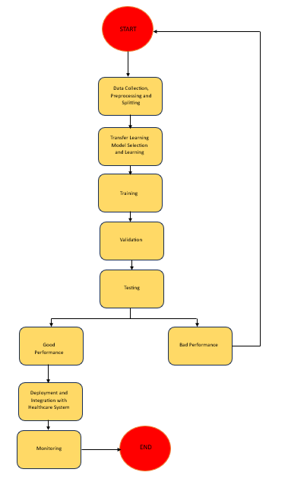

**RESULTS:**

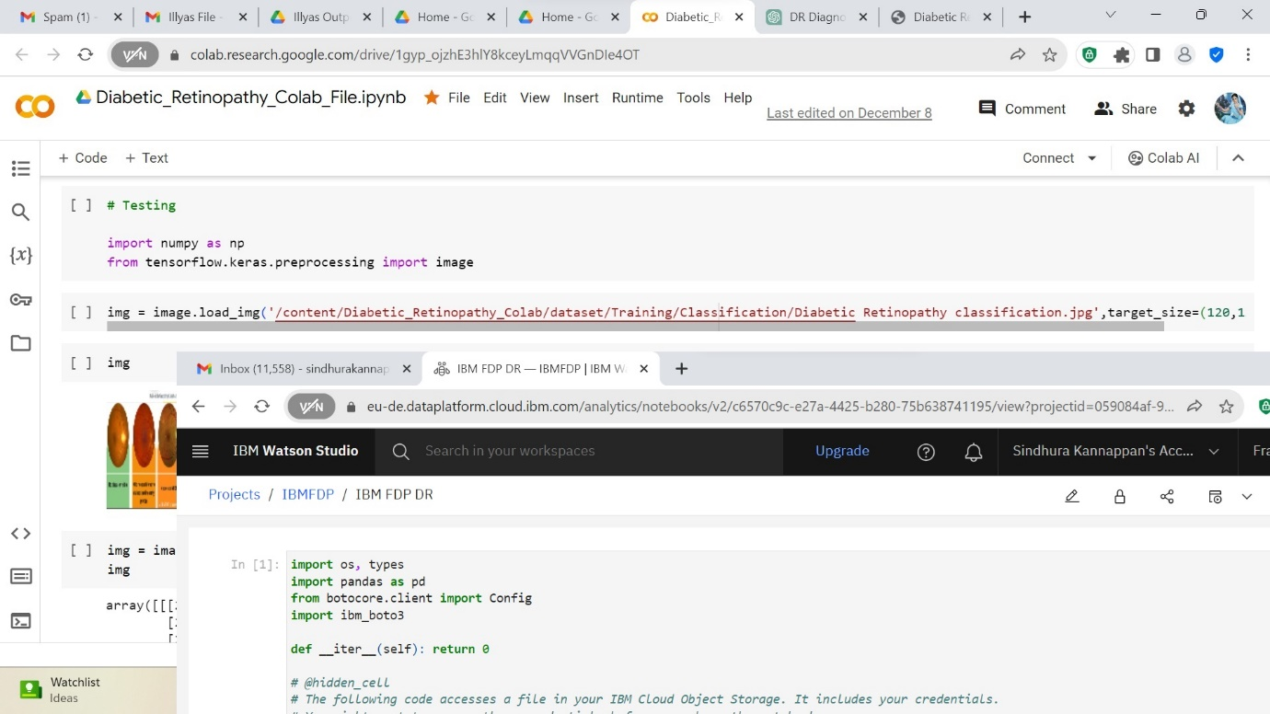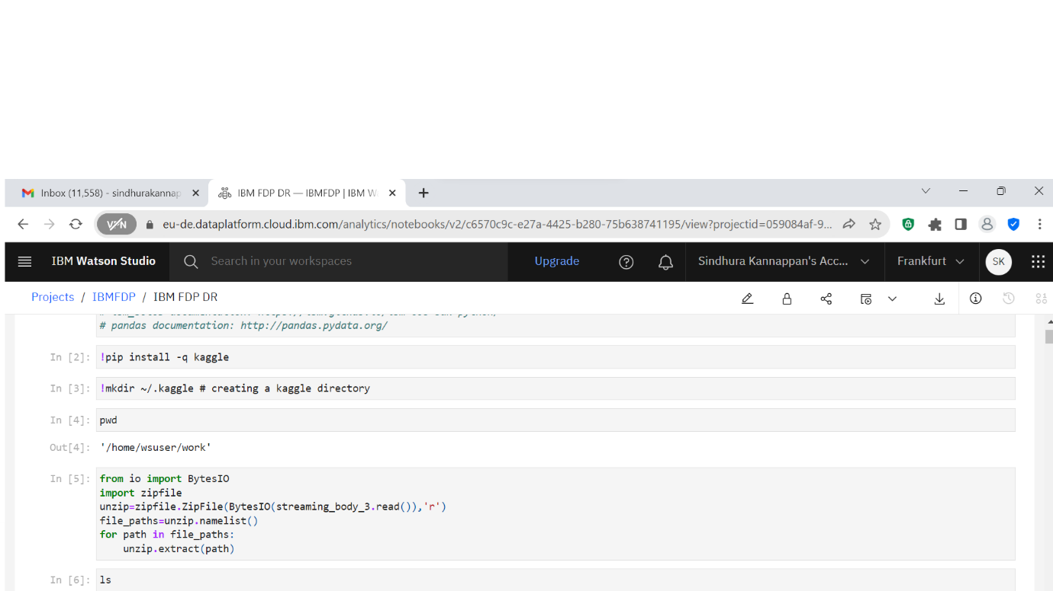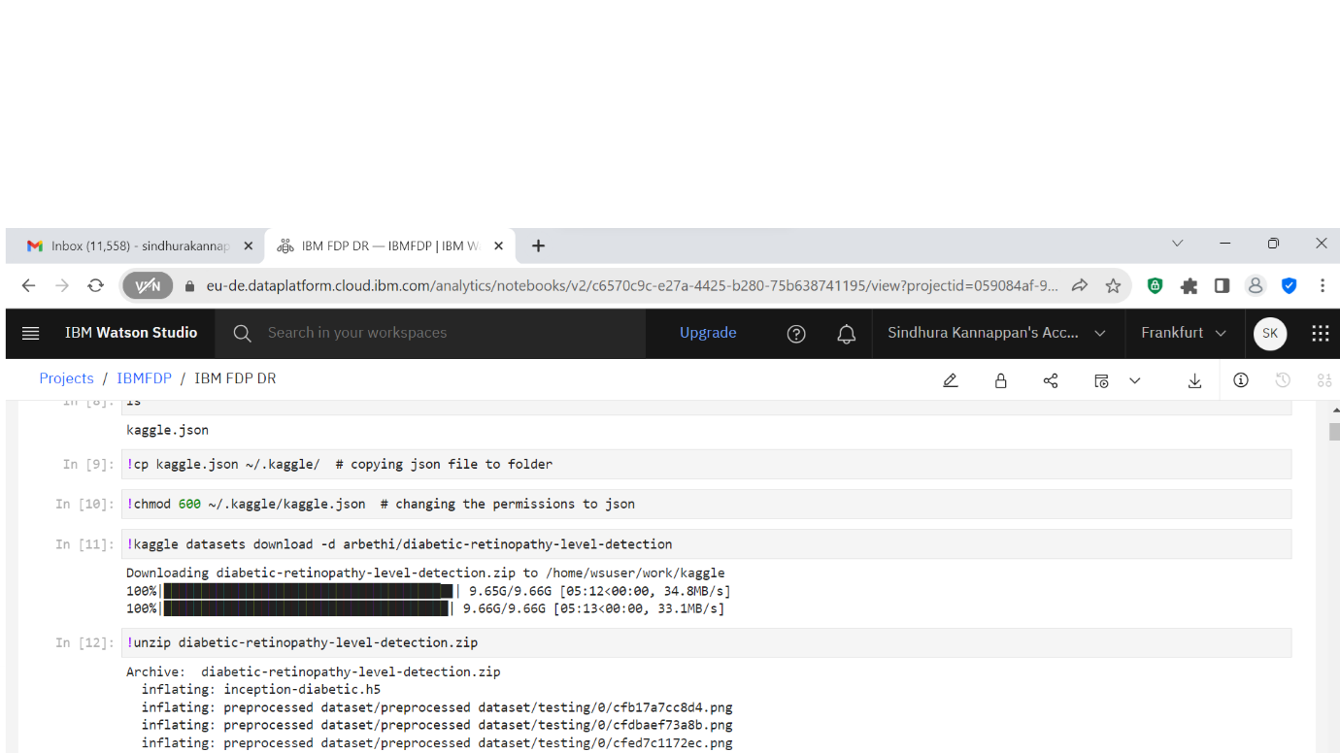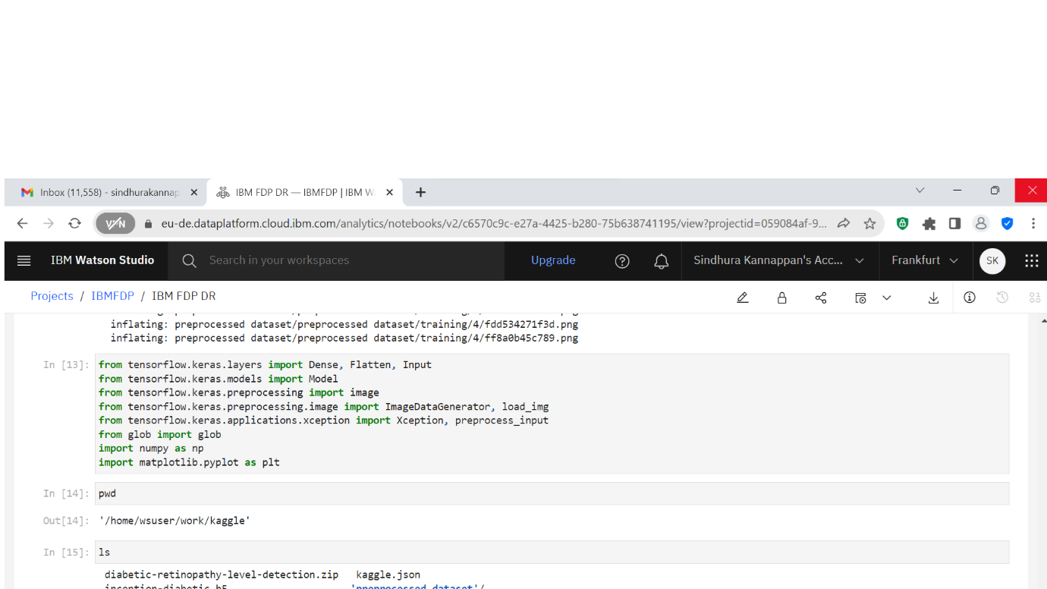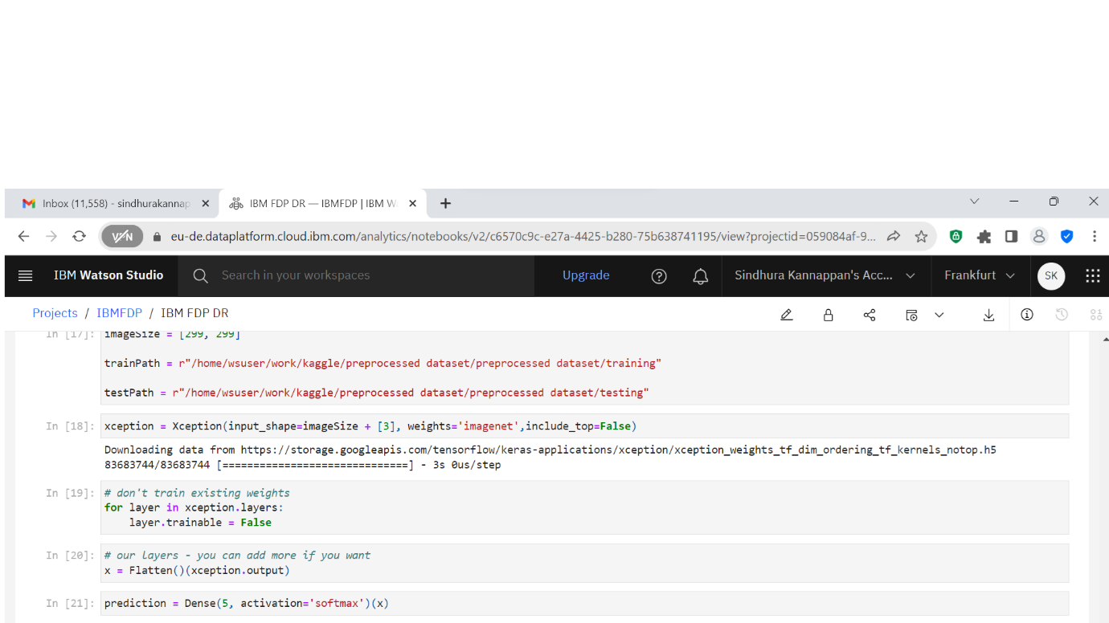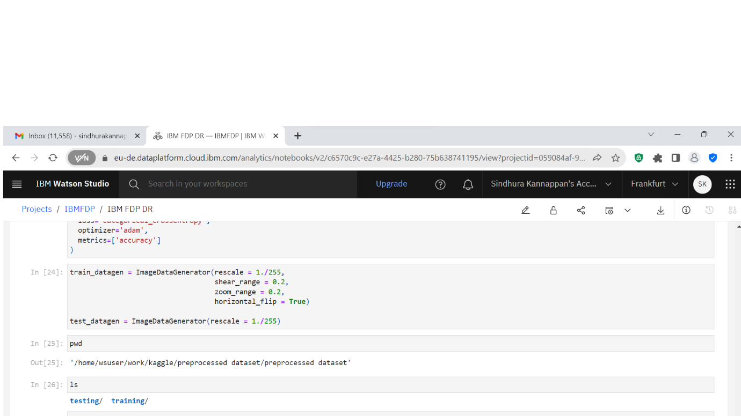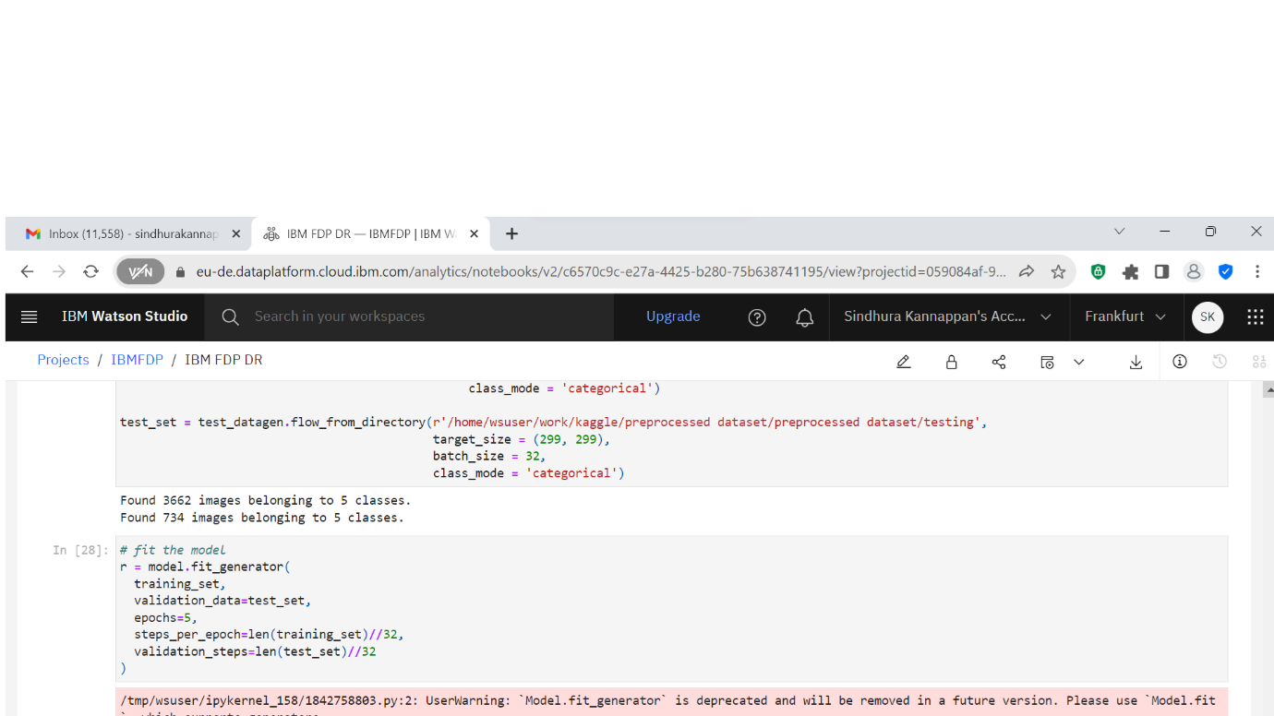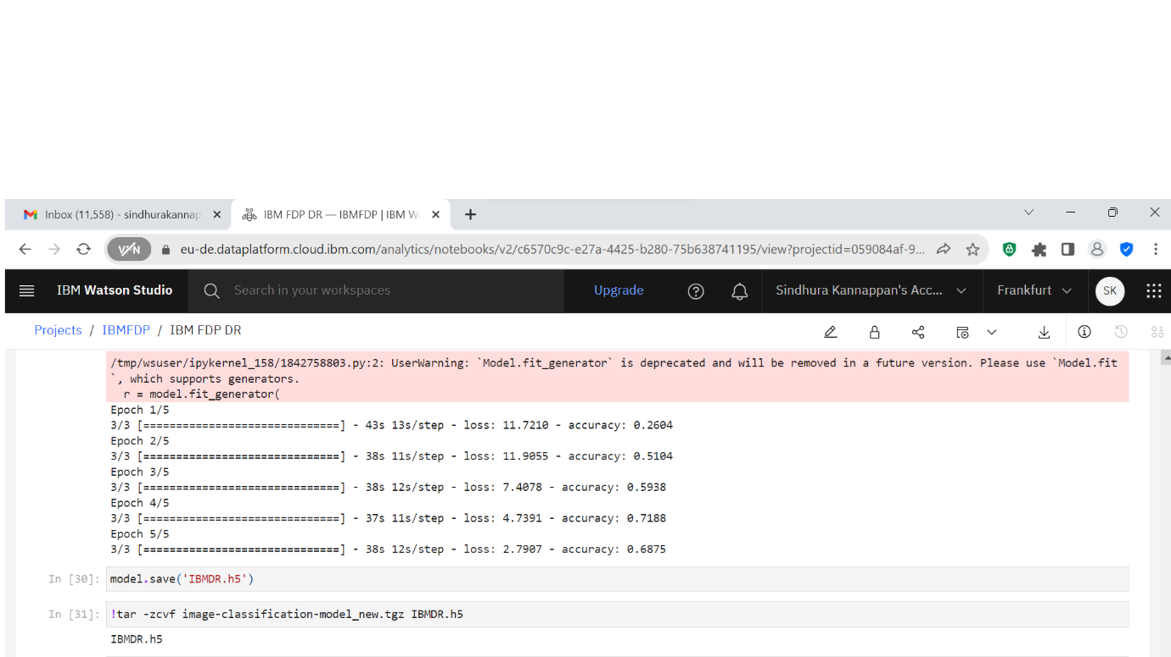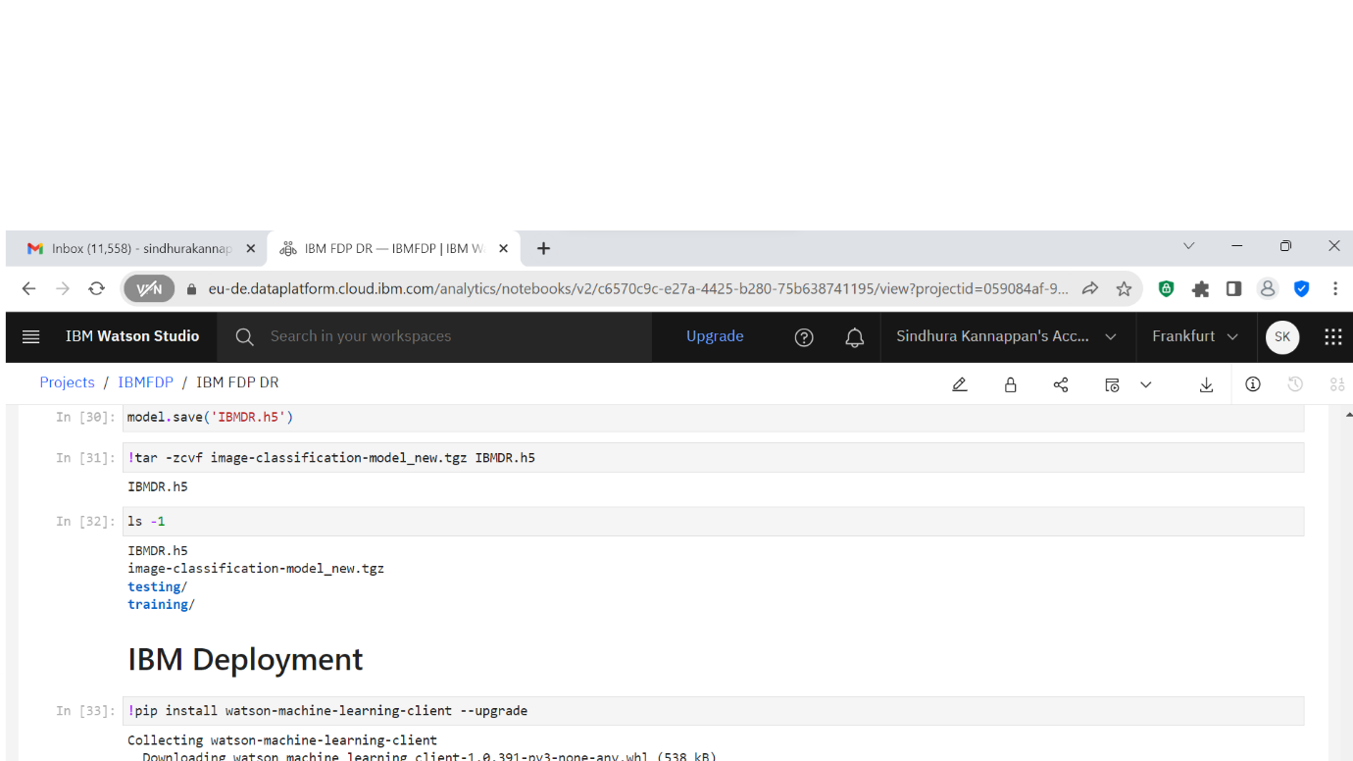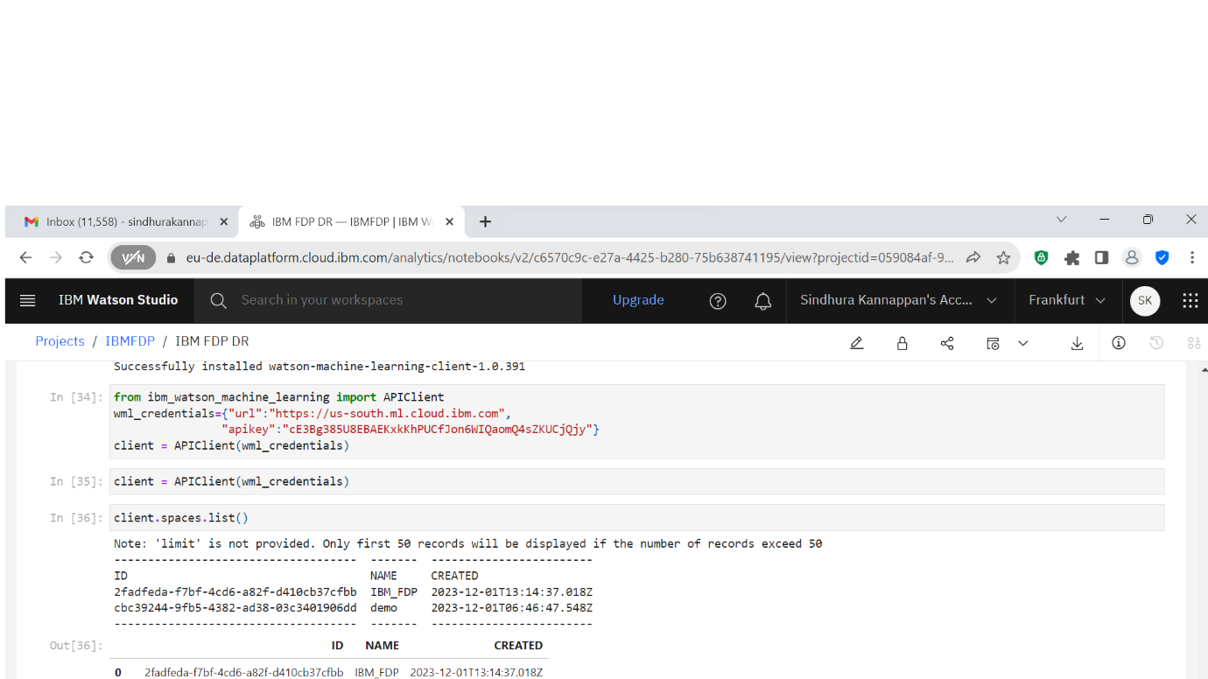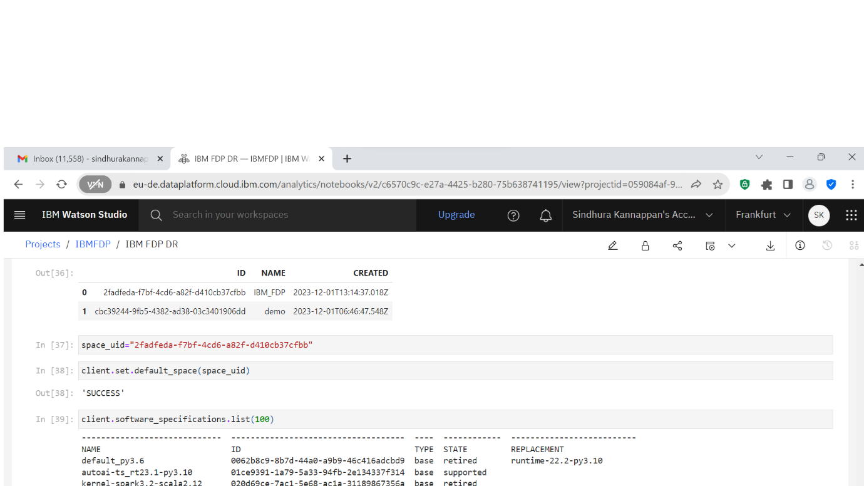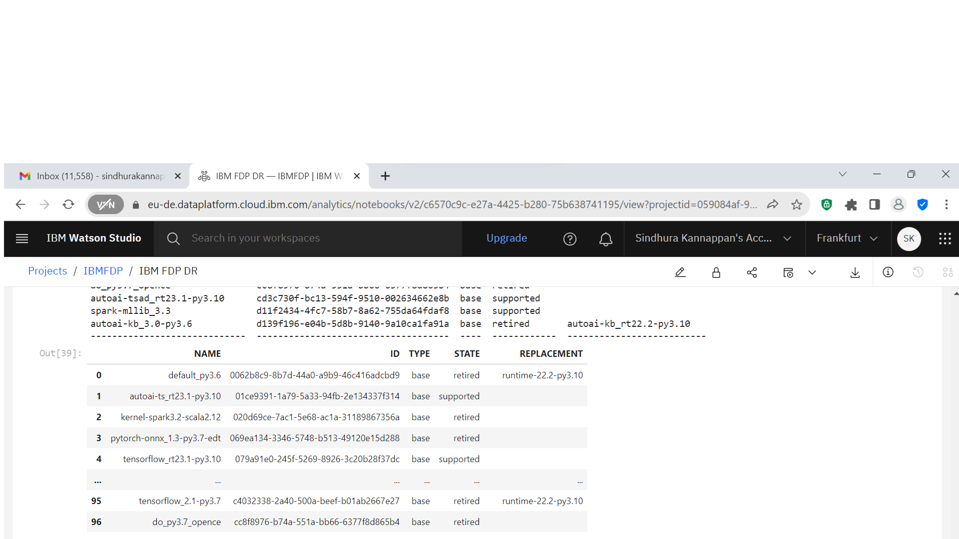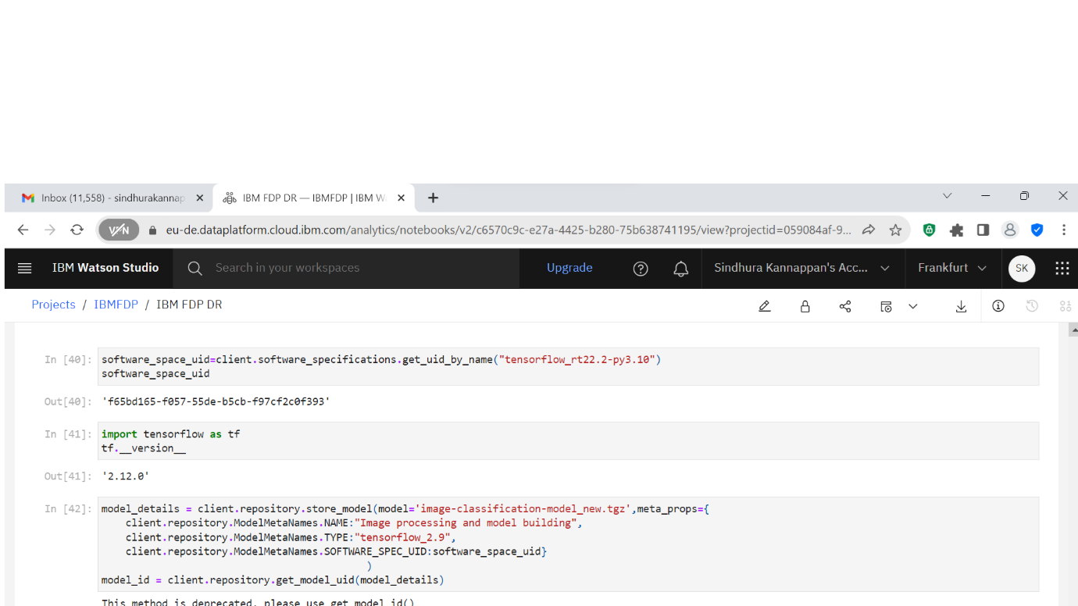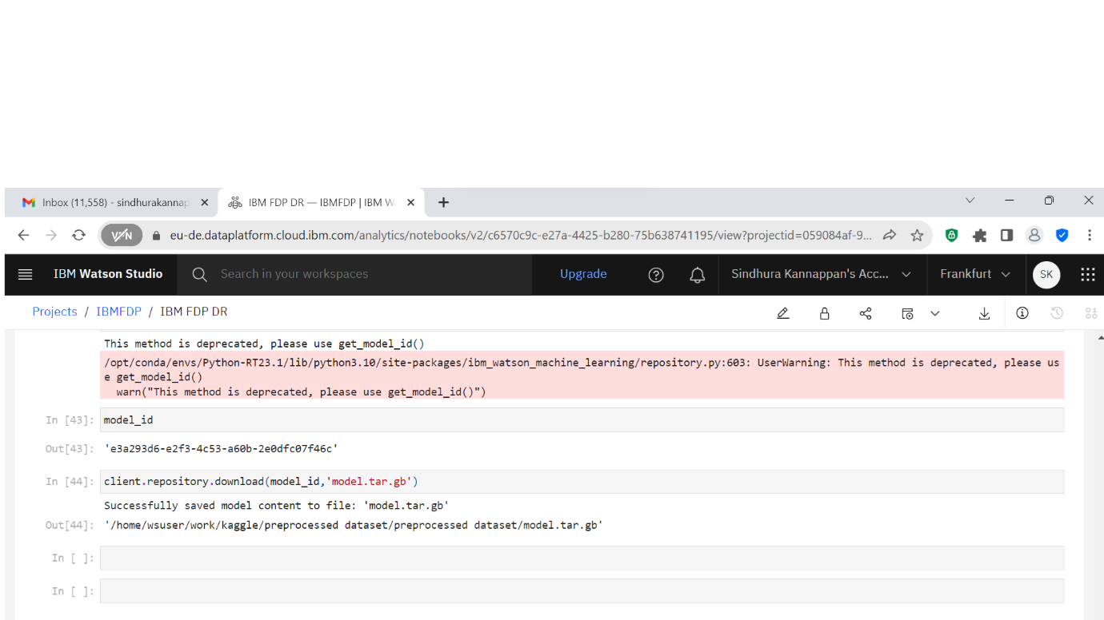

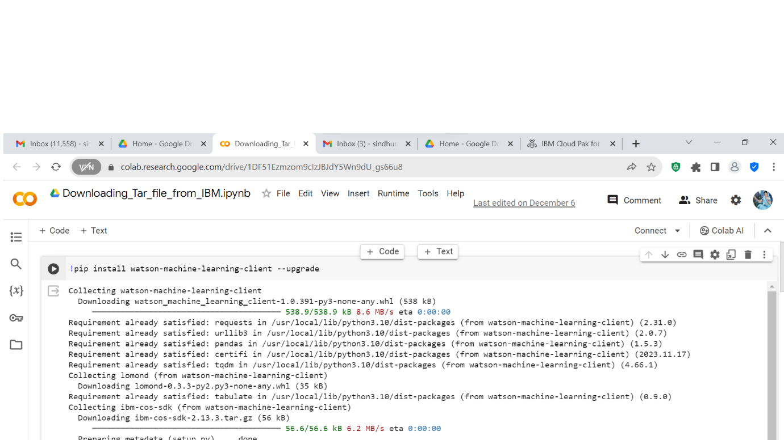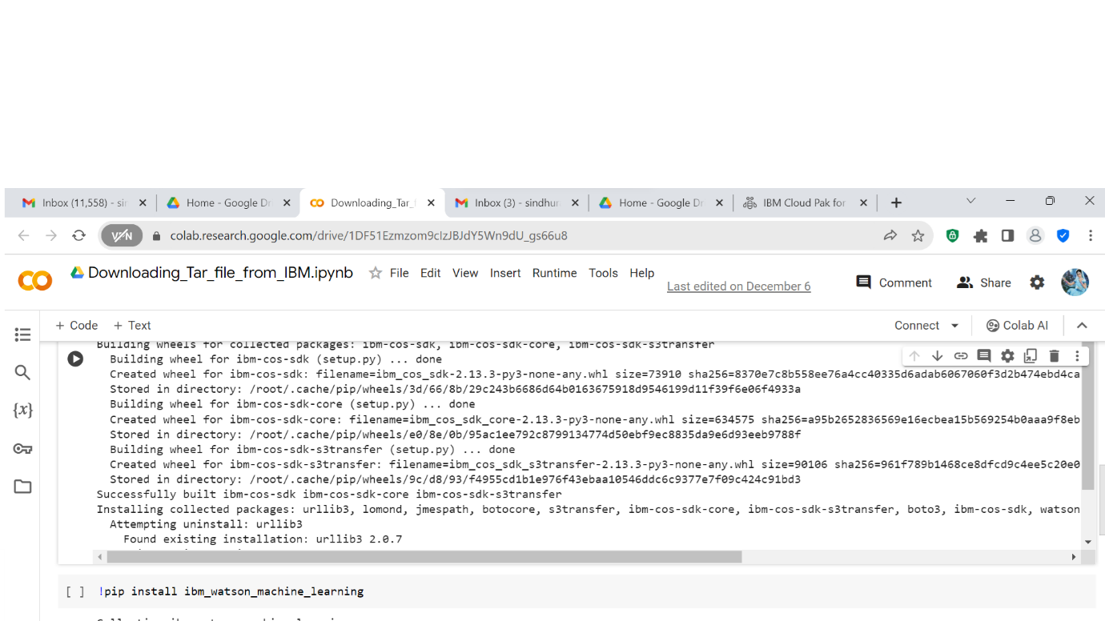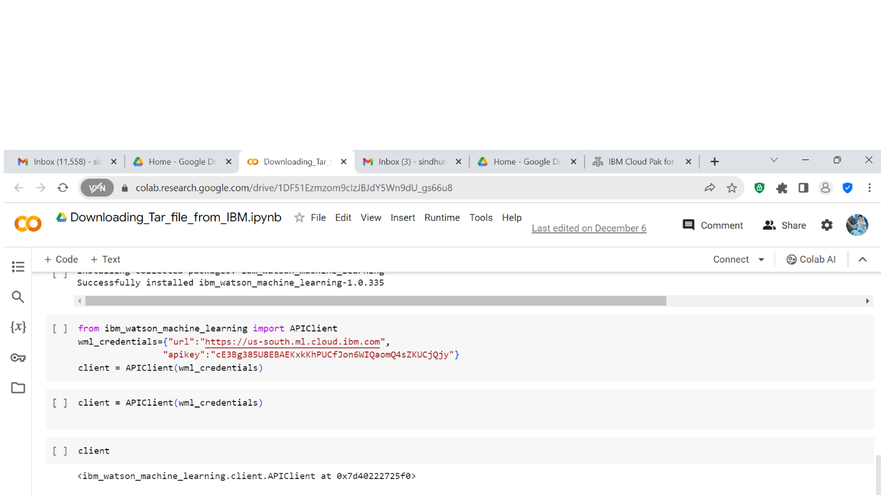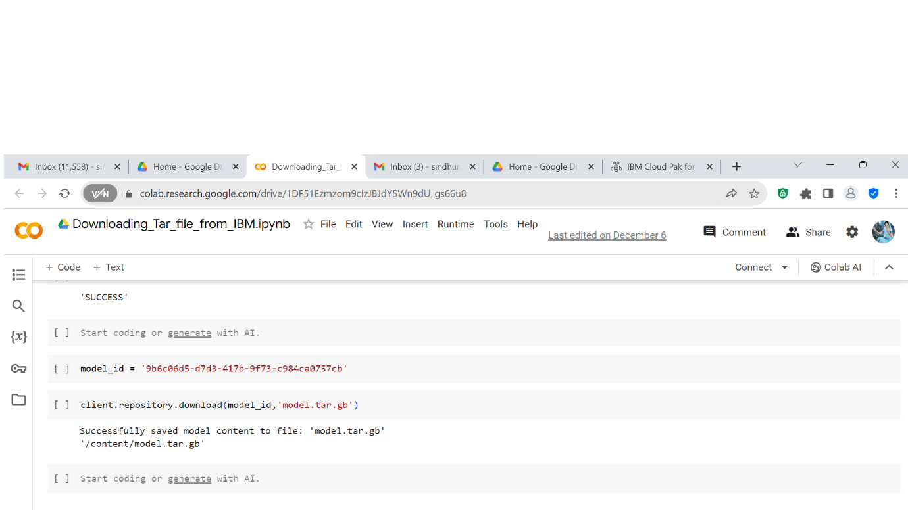

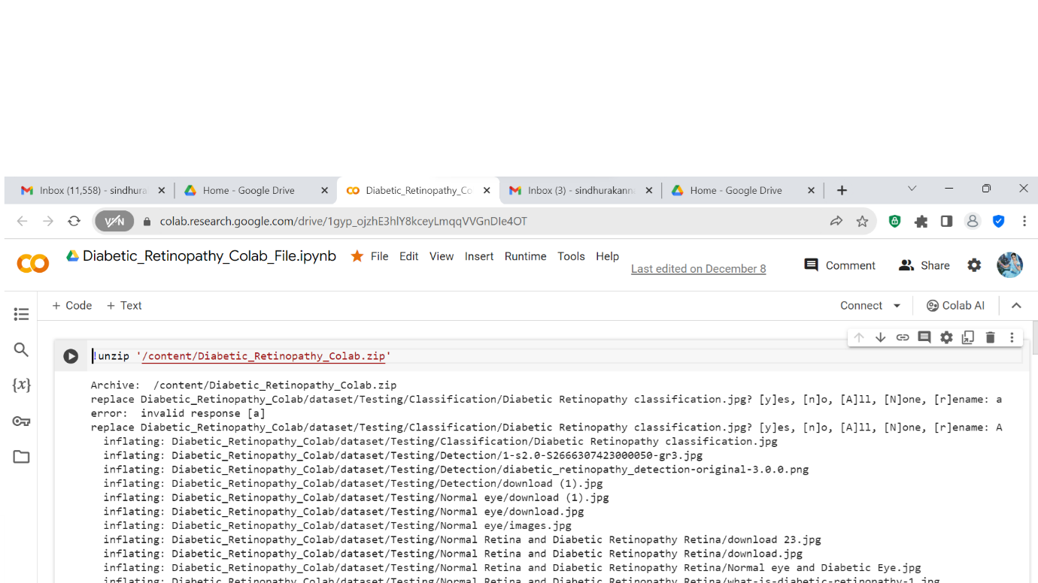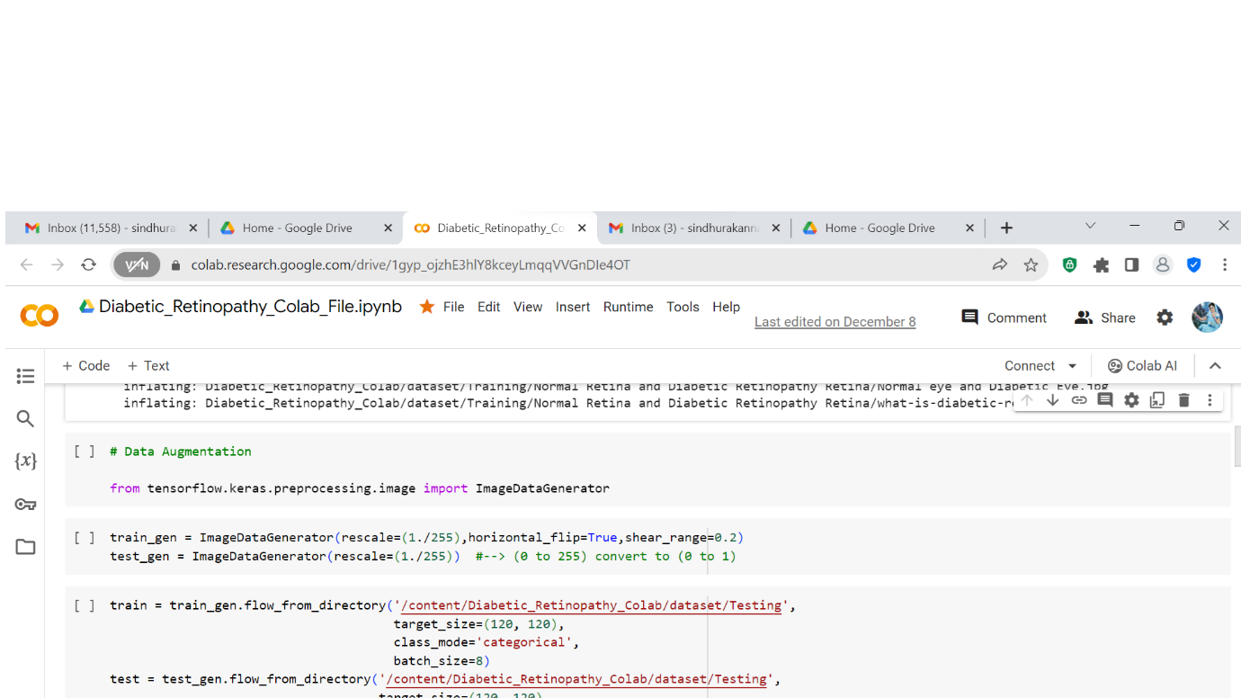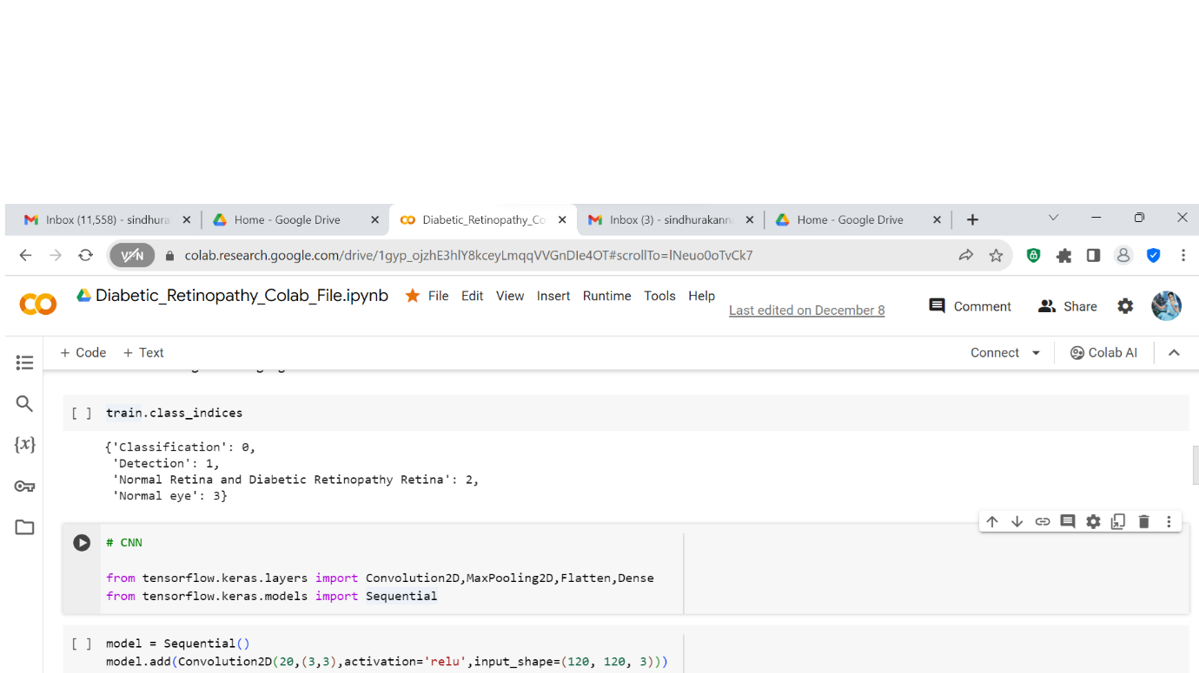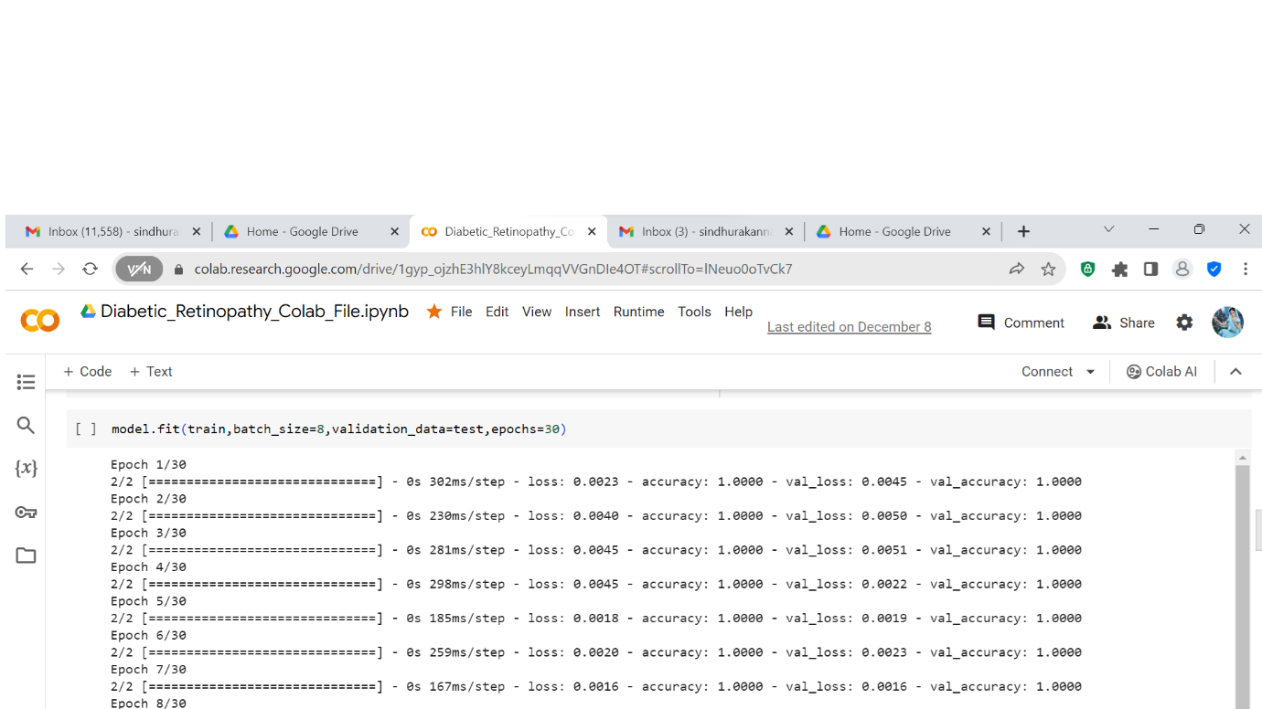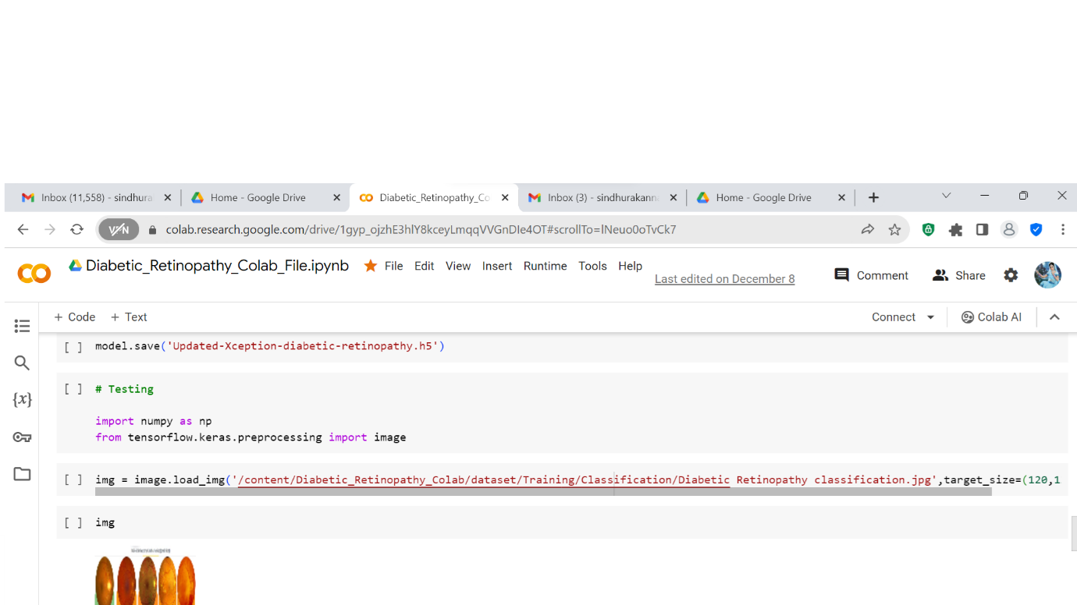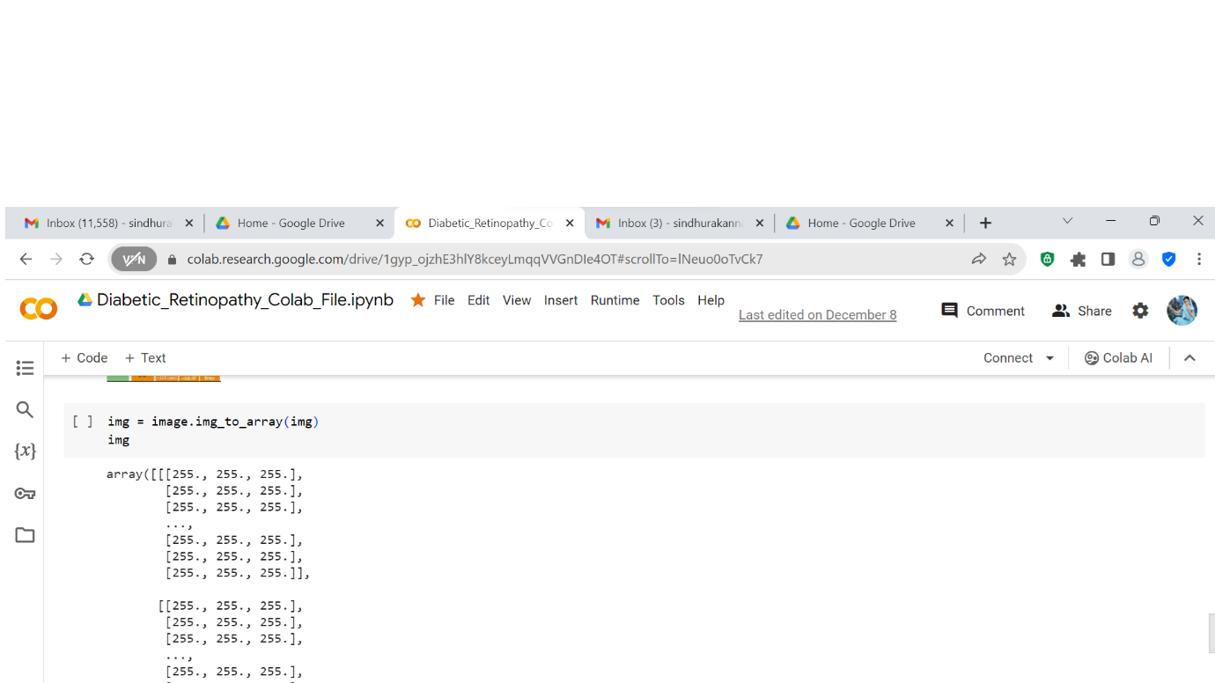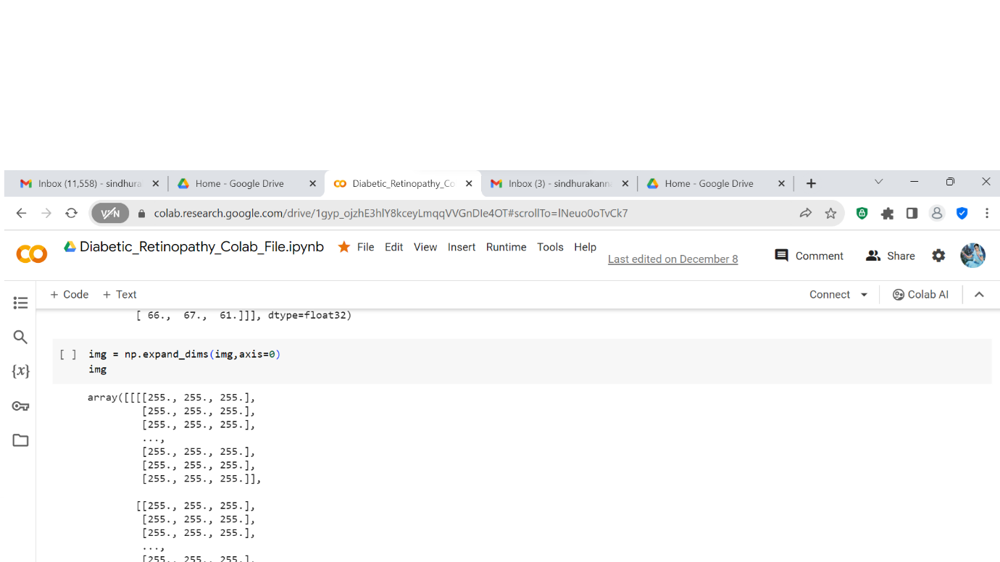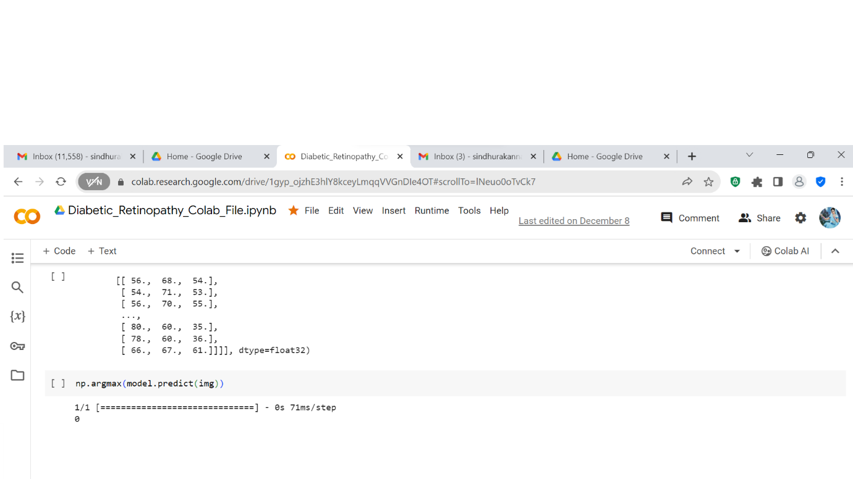

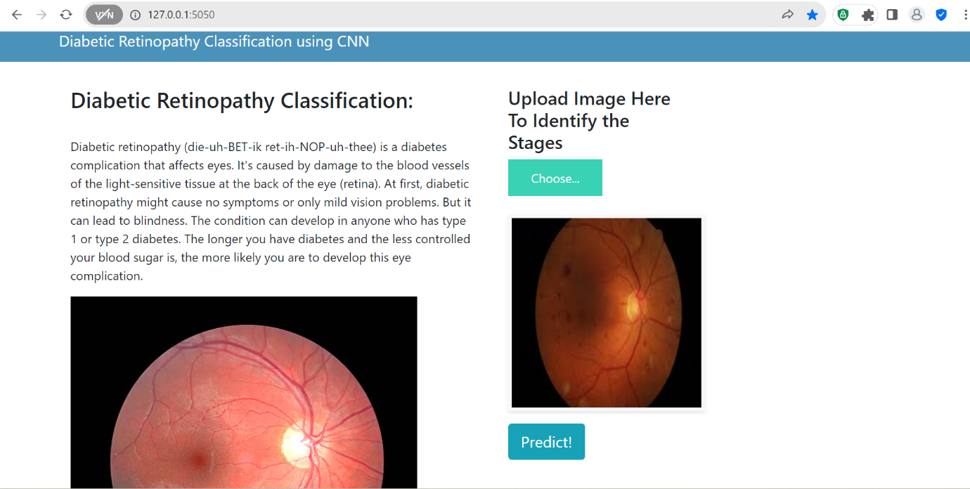

**ADVANTAGES AND DISADVANTAGES:**

Advantages of Deep Learning Fundus Image Analysis for Early Detection of Diabetic Retinopathy:

1. High Accuracy:

- Deep learning models, especially convolutional neural networks (CNNs), have demonstrated high accuracy in image analysis tasks, including diabetic retinopathy detection. They can learn intricate patterns and features from fundus images, leading to accurate predictions.

2. Automation and Efficiency:

- Deep learning systems can automate the analysis process, reducing the need for manual examination by ophthalmologists. This efficiency is crucial for handling the large volume of retinal images generated in diabetic retinopathy screening programs.

3. Early Detection and Intervention:

- Early detection of diabetic retinopathy is critical for timely intervention and preventing vision loss. Deep learning models can identify subtle changes in retinal images that may not be easily discernible through traditional methods, enabling early diagnosis and treatment.

4. Scalability:

- Deep learning algorithms can be trained on large datasets, allowing for scalability in screening programs. As the amount of available data increases, the models can potentially improve their performance and generalization to diverse patient populations.

5. Objective Analysis:

- Deep learning provides an objective and consistent approach to image analysis. The model's predictions are not influenced by subjective factors, leading to more standardized and reproducible results.

Disadvantages and Challenges:

1. Need for Large Datasets:

- Deep learning models, particularly for medical image analysis, often require large and diverse datasets for effective training. Collecting and curating such datasets, especially for rare conditions, can be challenging.

2. Interpretability:

- Deep learning models are often considered as "black boxes" due to their complex architectures. Interpreting the decisions made by these models, especially in the medical field, is a challenge. Understanding how a model arrived at a particular diagnosis is crucial for gaining trust from healthcare professionals.

3. Computational Resources:

- Training deep learning models, especially complex architectures, demands significant computational resources. Access to powerful hardware or cloud computing services may be required, and this can pose a barrier for some healthcare institutions.

4. Generalization Issues:

- Deep learning models may struggle with generalizing well to unseen data, especially if the training data is not representative of the broader population. Ensuring the model's robustness across different demographics and ethnicities is essential.

5. Ethical and Legal Concerns:

- The use of deep learning in medical diagnosis raises ethical concerns related to patient privacy, consent, and the responsible handling of sensitive health data. Additionally, legal implications regarding the reliability and accountability of automated diagnosis systems need careful consideration.

6. Integration into Clinical Workflow:

- Integrating deep learning models into the existing clinical workflow poses challenges. Establishing seamless collaboration between healthcare professionals and AI systems, as well as addressing issues related to user interfaces and real-time processing, is crucial.

**APPLICATIONS:**

Deep learning fundus image analysis for early detection of diabetic retinopathy has numerous applications, contributing to advancements in ophthalmology and healthcare. Some key applications include:

1. Early Diabetic Retinopathy Detection:

- The primary application is the early detection of diabetic retinopathy. Deep learning models analyze fundus images to identify subtle changes in the retina, enabling the diagnosis of diabetic retinopathy in its early stages when interventions are more effective.

2. Automated Screening Programs:

- Deep learning enables the development of automated screening programs for diabetic retinopathy. These systems can efficiently analyze large volumes of fundus images, identifying patients who require further examination by ophthalmologists.

3. Telemedicine and Remote Diagnostics:

- Fundus image analysis using deep learning facilitates telemedicine applications. Patients in remote or underserved areas can capture retinal images, which are then analyzed by deep learning models to provide early diabetic retinopathy assessments without the need for physical presence.

4. Personalized Treatment Plans:

- Deep learning models can assist in creating personalized treatment plans based on the severity and progression of diabetic retinopathy. This allows healthcare professionals to tailor interventions to the specific needs of each patient.

5. Progression Monitoring:

- Continuous monitoring of fundus images over time is essential for tracking the progression of diabetic retinopathy. Deep learning models can analyze sequential images, providing insights into how the disease evolves and guiding adjustments to treatment plans.

6. Integration into Electronic Health Records (EHR):

- Deep learning applications can seamlessly integrate with electronic health records, providing a comprehensive view of a patient's diabetic retinopathy history. This integration enhances the continuity of care and facilitates communication between healthcare providers.

7. Assistive Tools for Ophthalmologists:

- Deep learning serves as an assistive tool for ophthalmologists by providing rapid and accurate preliminary assessments. Ophthalmologists can leverage these tools to streamline their workflow, focusing on cases that require more in-depth analysis.

8. Education and Training:

- Deep learning models can be used in educational settings to train medical professionals, including ophthalmologists and technicians. They provide interactive tools for learning about diabetic retinopathy characteristics and the interpretation of fundus images.

9. Public Health Initiatives:

- Implementing deep learning in diabetic retinopathy screening contributes to public health initiatives aimed at preventing vision loss. Efficient screening programs can identify individuals at risk, allowing for timely interventions and reducing the overall burden on healthcare systems.

10. Research and Clinical Trials:

- Deep learning applications support research endeavors by providing quantitative and standardized measurements of diabetic retinopathy-related parameters. This is particularly valuable in clinical trials assessing the effectiveness of new treatments and interventions.

These applications collectively demonstrate the versatility and potential impact of deep learning in improving the early detection, management, and understanding of diabetic retinopathy, ultimately enhancing patient outcomes and reducing the prevalence of vision loss associated with the condition.

**FUTURE SCOPE:**

The future scope for deep learning in fundus image analysis for the early detection of diabetic retinopathy is promising and encompasses several exciting developments and advancements. Here are some potential future directions:

1. Enhanced Diagnostic Accuracy:

- Continued improvements in deep learning architectures and algorithms are expected to further enhance diagnostic accuracy. Fine-tuning models and incorporating advanced features may lead to even more reliable predictions, reducing false positives and false negatives.

2. Multi-Modal Integration:

- Future research may focus on integrating data from multiple imaging modalities, such as optical coherence tomography (OCT) and fundus fluorescein angiography (FFA). Combining information from diverse sources could provide a more comprehensive understanding of diabetic retinopathy and improve overall diagnostic capabilities.

3. Explainable AI (XAI) for Clinical Adoption:

- Addressing the interpretability challenge of deep learning models is crucial for their widespread clinical adoption. Future efforts may concentrate on developing explainable AI techniques that provide transparent insights into how models arrive at specific diagnoses, fostering trust among healthcare professionals.

4. Real-Time Diagnostics and Point-of-Care Devices:

- Advances in computational efficiency may lead to the development of real-time diagnostic tools for diabetic retinopathy. Point-of-care devices equipped with deep learning algorithms could enable quick and on-the-spot assessments, particularly in resource-limited settings and during telemedicine consultations.

5. Personalized Medicine Approaches:

- Deep learning models may be tailored to individual patient characteristics, considering factors such as genetics, lifestyle, and comorbidities. Personalized medicine approaches can lead to more targeted interventions and treatment plans, optimizing outcomes for patients with diabetic retinopathy.

6. Longitudinal Analysis and Predictive Modeling:

- Future research may focus on developing models capable of longitudinal analysis, predicting the progression of diabetic retinopathy over time. Predictive modeling could assist in identifying individuals at higher risk and allow for proactive management strategies.

7. Large-Scale Collaborative Databases:

- The creation of large-scale, diverse, and collaborative databases is essential for training and validating robust deep learning models. Future initiatives may involve global collaborations to build extensive datasets that capture the variability of diabetic retinopathy across different populations.

8. Integration with Wearable Devices:

- Integration with wearable devices, such as smart glasses or contact lenses with embedded sensors, could enable continuous monitoring of retinal health. Deep learning algorithms could process real-time data, providing timely alerts and interventions for individuals with diabetes.

9. Ethical AI and Patient Privacy:

- As the use of deep learning in healthcare expands, there will be a heightened focus on ethical considerations and patient privacy. Future developments may involve the implementation of robust ethical frameworks and privacy-preserving techniques to ensure responsible and secure use of patient data.

10. Collaboration with Multidisciplinary Teams:

- The future of diabetic retinopathy management may involve increased collaboration between ophthalmologists, data scientists, endocrinologists, and other healthcare professionals. This multidisciplinary approach can lead to holistic patient care and comprehensive solutions.

In summary, the future scope for deep learning in diabetic retinopathy analysis includes advancements in accuracy, explainability, real-time diagnostics, personalized medicine, longitudinal analysis, collaborative databases, wearable technology integration, ethical considerations, and interdisciplinary collaboration. These developments hold the potential to significantly impact the field, improving patient outcomes and contributing to the broader landscape of AI in healthcare.

**CONCLUSION:**

In conclusion, the application of deep learning in fundus image analysis for the early detection of diabetic retinopathy represents a transformative and promising advancement in the field of ophthalmology and healthcare. The integration of artificial intelligence, particularly deep learning models, has brought about significant improvements in the accuracy, efficiency, and accessibility of diabetic retinopathy diagnosis.

The advantages of deep learning, including its ability to analyze vast amounts of data, make complex associations, and automate the detection process, have paved the way for early identification of diabetic retinopathy. This early detection is crucial for timely interventions, ultimately reducing the risk of vision loss in individuals with diabetes.

However, challenges such as the need for large and diverse datasets, interpretability of deep learning models, and ethical considerations regarding patient privacy remain focal points for future research and development. Efforts to address these challenges will be instrumental in furthering the integration of deep learning into clinical practice.

Looking ahead, the future scope of deep learning in diabetic retinopathy analysis holds exciting possibilities. Advances in diagnostic accuracy, multi-modal integration, real-time diagnostics, personalized medicine, and collaboration with wearable devices are on the horizon. The ongoing pursuit of explainable AI, ethical considerations, and multidisciplinary collaboration will contribute to the responsible and effective implementation of these technologies in patient care.

As deep learning continues to evolve, it is anticipated to play a pivotal role in shaping the landscape of diabetic retinopathy management, offering not only improved diagnostic capabilities but also contributing to the broader paradigm of data-driven, personalized healthcare. The journey toward leveraging the full potential of deep learning in diabetic retinopathy analysis underscores a commitment to advancing patient outcomes, enhancing accessibility to healthcare, and fostering innovation in the intersection of medicine and artificial intelligence.

**REFERENCES:**

1. Gulshan, V., Peng, L., Coram, M., et al. (2016). Development and Validation of a Deep Learning Algorithm for Detection of Diabetic Retinopathy in Retinal Fundus Photographs. JAMA, 316(22), 2402–2410.

2. Abràmoff, M. D., Lavin, P. T., Birch, M., Shah, N., & Folk, J. C. (2010). Pivotal trial of an autonomous AI-based diagnostic system for detection of diabetic retinopathy in primary care offices. NPJ Digital Medicine, 3(1), 1–8.

3. Gargeya, R., & Leng, T. (2017). Automated Identification of Diabetic Retinopathy Using Deep Learning. Ophthalmology, 124(7), 962–969.

4. Li, Z., Keel, S., Liu, C., et al. (2019). An automated grading system for detection of vision-threatening referable diabetic retinopathy on the basis of color fundus photographs. Diabetes Care, 42(1), 16–24.

5. Kermany, D. S., Goldbaum, M., Cai, W., et al. (2018). Identifying Medical Diagnoses and Treatable Diseases by Image-Based Deep Learning. Cell, 172(5), 1122–1131.

6. Rajalakshmi, R., Subashini, R., Anjana, R. M., Mohan, V., & Sudha, V. (2017). Automated diabetic retinopathy detection in smartphone-based fundus photography using artificial intelligence. Eye, 31(12), 1468–1474.

7. Burlina, P. M., Joshi, N., Pekala, M., Pacheco, K. D., Freund, D. E., & Bressler, N. M. (2017). Automated grading of age-related macular degeneration from color fundus images using deep convolutional neural networks. JAMA Ophthalmology, 135(11), 1170–1176.

8. Gargeya, R., & Leng, T. (2017). Automated Identification of Diabetic Retinopathy Using Deep Learning. Ophthalmology, 124(7), 962–969.

9. Korot, E., Elad, M., & Werman, M. (2016). From retinal image analysis to computerized diagnosis of ophthalmic pathologies. Computers in Biology and Medicine, 74, 45–59.

10. Ting, D. S. W., Cheung, C. Y., Lim, G., et al. (2017). Development and Validation of a Deep Learning System for Diabetic Retinopathy and Related Eye Diseases Using Retinal Images From Multiethnic Populations With Diabetes. JAMA, 318(22), 2211–2223.

11. Gupta, R., Zhang, Z., Castellanos, N., & Rao, N. A. (2019). Automating Diabetic Retinopathy Screening Using Artificial Intelligence. Ophthalmology, 126(11), 1528–1530.

12. Tufail, A., Rudisill, C., Egan, C., et al. (2017). Automated Diabetic Retinopathy Image Assessment Software: Diagnostic Accuracy and Cost-Effectiveness Compared with Human Graders. Ophthalmology, 124(3), 343–351.

13. Poplin, R., Varadarajan, A. V., Blumer, K., et al. (2018). Prediction of cardiovascular risk factors from retinal fundus photographs via deep learning. Nature Biomedical Engineering, 2(3), 158–164.

14. Liu, Y., Gadepalli, K., Norouzi, M., Dahl, G. E., Kohlberger, T., Boyko, A., & Stumpe, M. C. (2018). Detecting Cancer Metastases on Gigapixel Pathology Images. arXiv preprint arXiv:1703.02442.

15. Ronneberger, O., Fischer, P., & Brox, T. (2015). U-Net: Convolutional Networks for Biomedical Image Segmentation. In International Conference on Medical Image Computing and Computer-Assisted Intervention (MICCAI) (pp. 234–241). Springer.